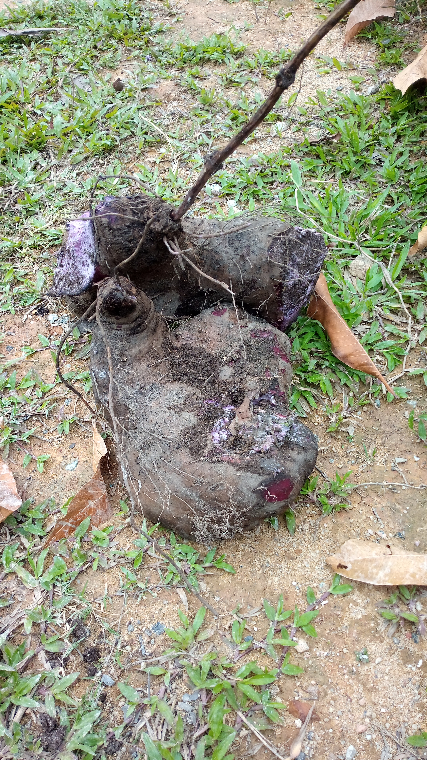
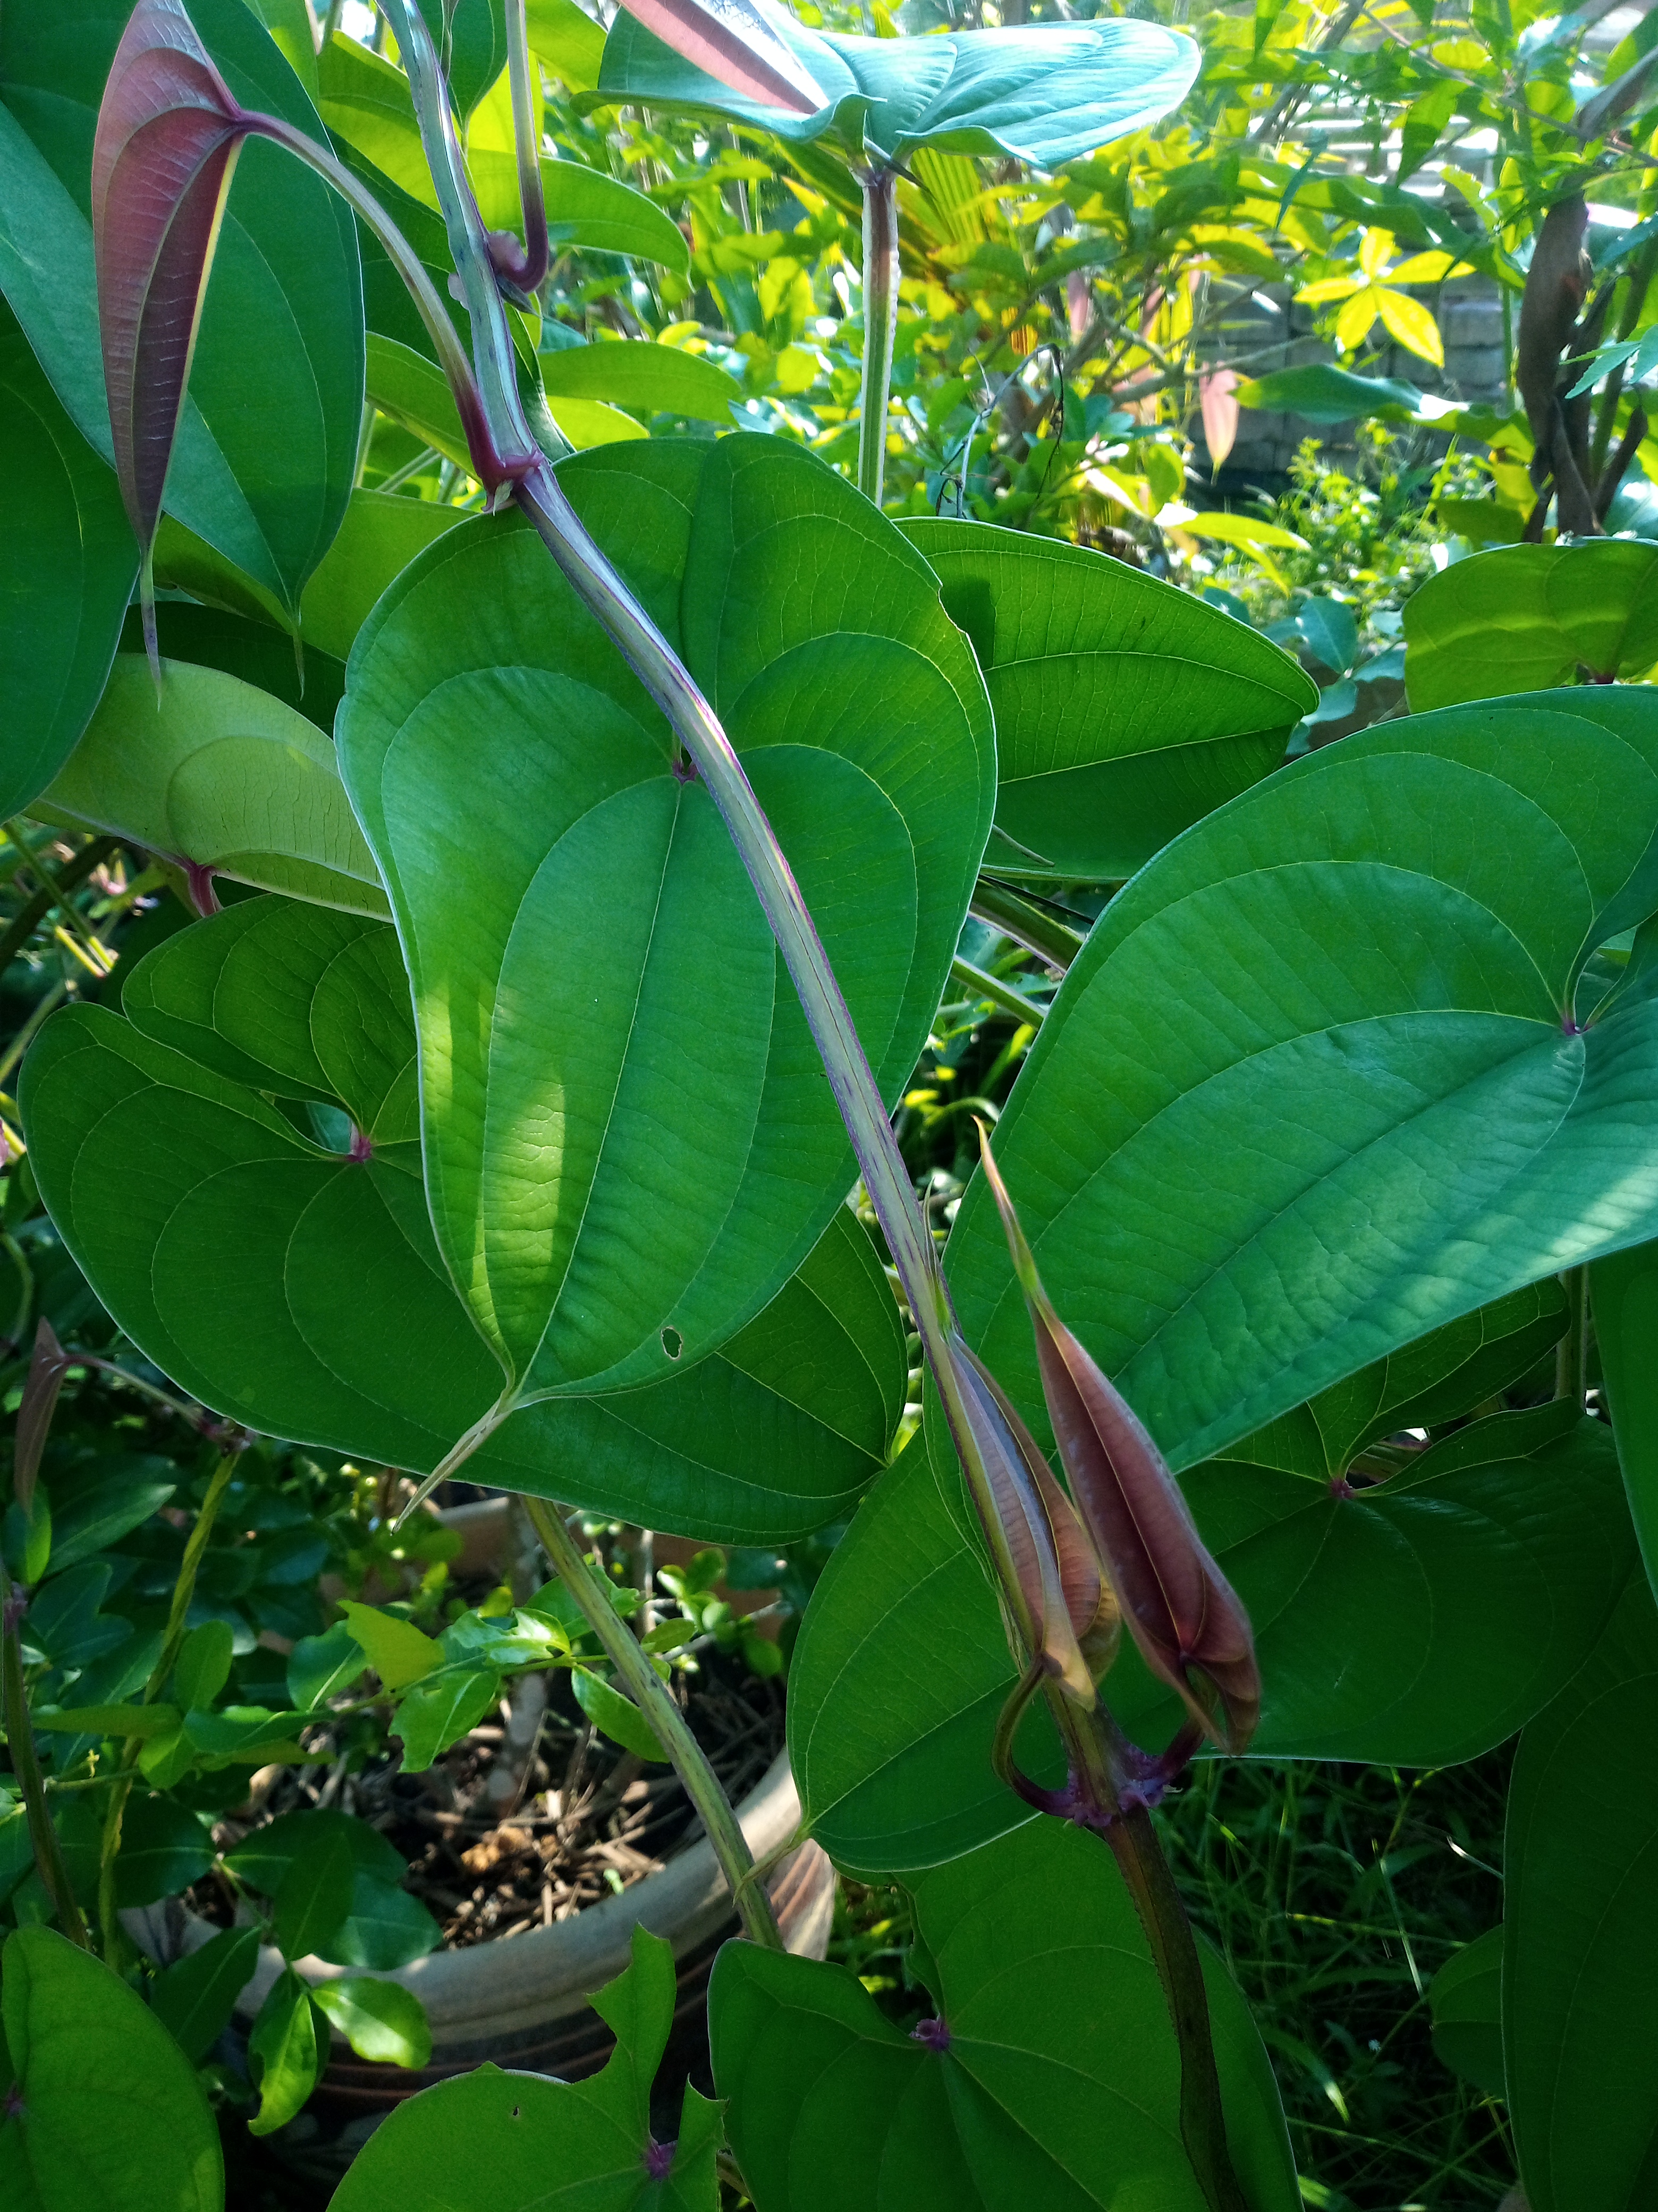
True yam ( dioscorea alata ) are edible tubers distinct from sweet potatoes or taro. It is a stable food particularly in West Africa and parts of Asia. They are edible subterranean tubers (yams) that can be purple, white, or creamy-white in colour.

